A dynamic and caring community committed to enacting our faith; inspiring, challenging and engaging lifelong learners.
(excellence, integrity, inclusiveness, respect)

Anaphylaxis Management Policy

Rationale:
Anaphylaxis is a severe, rapidly progressing allergic reaction that is potentially life threatening. The most common allergens in school aged children are peanuts, eggs, tree nuts (e.g. cashews), cow’s milk, fish and shellfish, wheat, soy, sesame, latex, certain insect stings and medication.

The key to prevention of anaphylaxis in schools is knowledge of those students who have been diagnosed as being at risk, awareness of triggers (allergens), and prevention of exposure to these triggers. Partnerships between schools and parents are important in ensuring that certain foods or items are kept away from the student while at school.

Aim:
- To fully comply with the Ministerial Order 706 – Anaphylactic Management in Schools and Anaphylaxis Guidelines Anaphylaxis Guidelines - Victorian Schools

- To provide, as far as practicable, a safe and supportive environment in order to minimise the risk of an anaphylactic reaction.

- To ensure that in the event of an anaphylactic reaction, the school’s first aid and management response procedures and the student’s individual Anaphylaxis Management Plan will be followed.

- To engage with parents/carers of students at risk of anaphylaxis in assessing risks, developing risk minimisation strategies and management strategies for the student.

- To ensure that school staff have regular training in recognising and responding appropriately to an anaphylactic reaction, including competently administering an EpiPen.

Staff Training:
All staff at Mary Immaculate Primary School will meet the anaphylaxis training requirements of MO706 through either face-to-face training onsite by an accredited facilitator or through ACSIA Anaphylaxis e-training for Victorian Schools, followed by a competency check by a School Anaphylaxis Supervisor – this capability must be tested within 30 days of completion of the online course. In addition, two staff are nominated as School Anaphylaxis Supervisors and will complete the Course in Verifying the Correct Use of Adrenaline Autoinjector Devices 22303VIC. The online training course will need to be repeated, together with the autoinjector competency assessment, every two years.

In addition, all staff will participate in a briefing, to occur twice per calendar year, with the first briefing to be held at the beginning of the school year on:
- legal requirements as outlined in Ministerial Order 706
- pictures of the students at your school at risk of anaphylaxis, their allergens, year levels and risk management plans that are in place
- signs and symptoms of anaphylaxis
- ASCIA Anaphylaxis e-training
- ASCIA Action Plan for Anaphylaxis and how to administer an EpiPen®
- the school’s First Aid policy and emergency response procedures
- on-going support and training.

The briefing will be conducted by a member of the school staff who is nominated as a School Anaphylaxis Supervisor and/or the Principal, and who has successfully completed an approved anaphylaxis management training course in the last two years.

The Principal will ensure that while the student is under the care or supervision of the school, including excursions, yard duty, camps and special event days, there is a sufficient number of school staff present who have successfully completed an anaphylaxis management training course.

Management Plans
The Principal will ensure that an Individual Anaphylaxis Management Plan is developed, in consultation with the students’ parents, for any student who has been diagnosed by a Medical Practitioner as being at risk of anaphylaxis. The Individual Anaphylaxis Management Plan will be in place as soon as practicable after the student enrols and where possible, before their first day of school. A blank copy of an Individual Anaphylaxis Management Plan will be part of the Beginning of the Year Pack.

The individual anaphylaxis management plan will set out the following:
- information about the student’s medical condition that relates to allergy and the potential for anaphylactic reaction, including the type of allergy/allergies the student has and the signs or symptoms the student might exhibit in the event of an allergic reaction (based on a written diagnosis from a medical practitioner)
- strategies to minimise the risk of exposure to known allergens while the student is under the care or supervision of school staff, for in-school and out-of-school settings including in the school yard, at camps and excursions, or at special events conducted, organised or attended by the school
- the name of the person(s) responsible for implementing the risk minimisation strategies which have been identified in the Plan
- information on where the student's medication will be stored
- the student's emergency contact details
- an up-to-date ASCIA Action Plan for Anaphylaxis completed by the student’s medical practitioner.
- Note: The red and blue ‘ASCIA Action Plan for Anaphylaxis’ is the recognised form for emergency procedure plans that is provided by medical practitioners to parents when a child is diagnosed as being at risk of anaphylaxis. An example can be

- found in Appendix E of the Anaphylaxis Guidelines or downloaded from www.education.vic.gov.au/school/teachers/health/Pages/anaphylaxisschl.aspx

School staff will implement and monitor the student’s Individual Anaphylaxis Management Plan as required.

The student’s Individual Anaphylaxis Management Plan will be reviewed, in consultation with the student’s parents in all of the following circumstances:
- Annually (Beginning of the Year Pack)
- if the student's medical condition, insofar as it relates to allergy and the potential for anaphylactic reaction, changes
- as soon as practicable after the student has an anaphylactic reaction at school
- when the student is to participate in an off-site activity, such as camps and excursions, or at special events conducted, organised or attended by the school (eg. class parties, elective subjects and work experience, cultural days, fetes, concerts, events at other schools, competitions or incursions).
It is the responsibility of parents to:
- obtain the ASCIA Action Plan for Anaphylaxis from the student’s medical practitioner and provide a copy to the school as soon as practicable
- immediately inform the school in writing if there is a change in their child’s medical condition, insofar as it relates to allergy and the potential for anaphylactic reaction, and if relevant obtain an updated ASCIA Action Plan for Anaphylaxis
- provide an up to date photo of the student for the ASCIA Action Plan for Anaphylaxis when that Plan is provided to the school and each time it is reviewed
- provide the school with an adrenaline autoinjector that is current (ie the device has not expired) for their child
- participate in annual reviews of their child’s Plan.

Risk Minimisation Strategies
Parents can assist their child’s school to manage the risk of anaphylaxis. For example, parents must:
• communicate their child's allergies and risk of anaphylaxis to the school at the earliest opportunity, in writing and preferably on enrolment
• continue to communicate with school staff and provide up to date information about their child’s medical condition and risk factors
• obtain and provide the school with an ASCIA Action Plan for Anaphylaxis completed by a medical practitioner
• participate in yearly reviews of their child’s Individual Anaphylaxis Management Plan
• ensure that their child has an adrenaline autoinjector at school at all times that is current (i.e. the device has not expired).

Peanuts and nuts are the most common trigger for an anaphylactic reaction or fatality due to food-induced anaphylaxis. To minimise the risk of a student’s exposure and reaction to peanuts and nuts, Mary Immaculate School does not use peanuts, tree nuts, peanut butter or other peanut or tree nut products during in-school and out-of school activities and so aim to be as ‘nut free’ as possible. School activities are

planned and conducted so that they do not place pressure on students to try foods, whether they contain a known allergen or not.

School staff will be regularly reminded through ongoing training and biannual briefings, that they have a duty of care to take reasonable steps to protect students from reasonably foreseeable risks of injury.

Mary Immaculate School will implement the following risk minimisation recommendations for schools as outlined in Appendix F of ‘Anaphylaxis Guidelines – A Resource for Managing Allergies in Victorian Schools (Vic. Gov. – 2015):

In-school Settings

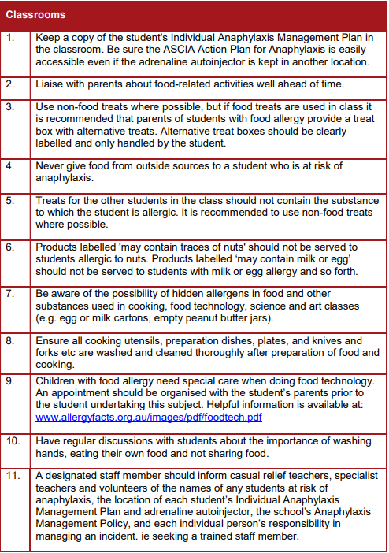

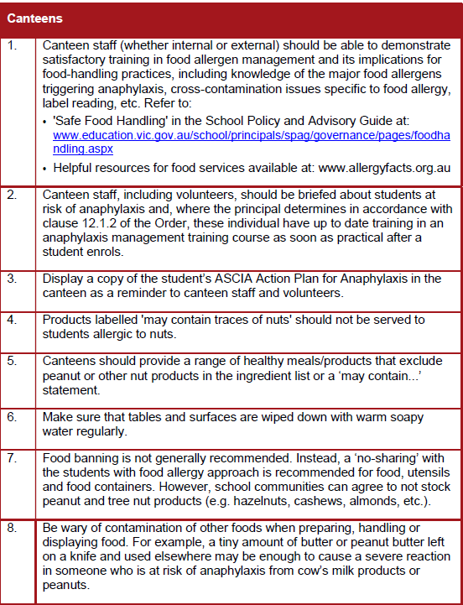

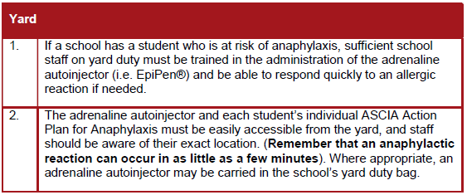
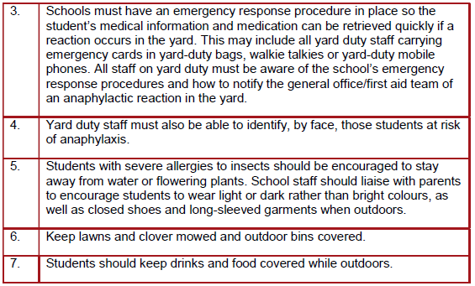

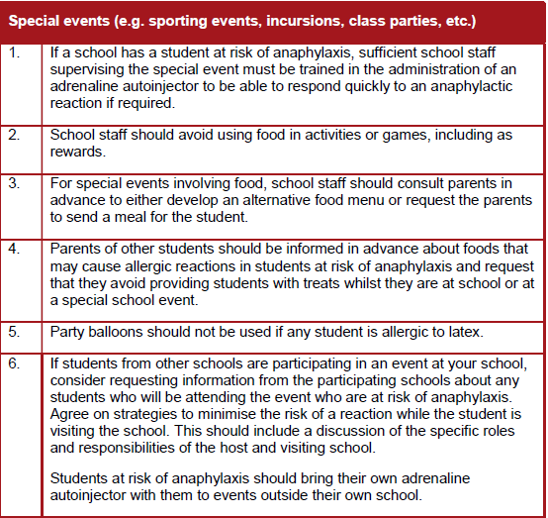

Out of School Settings

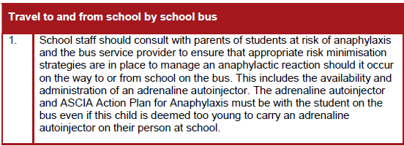

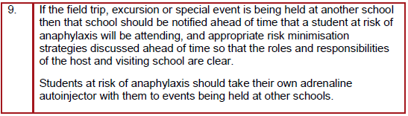

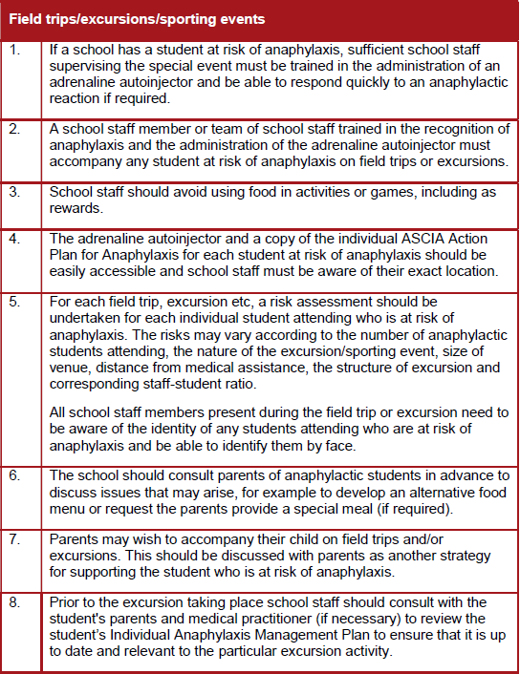

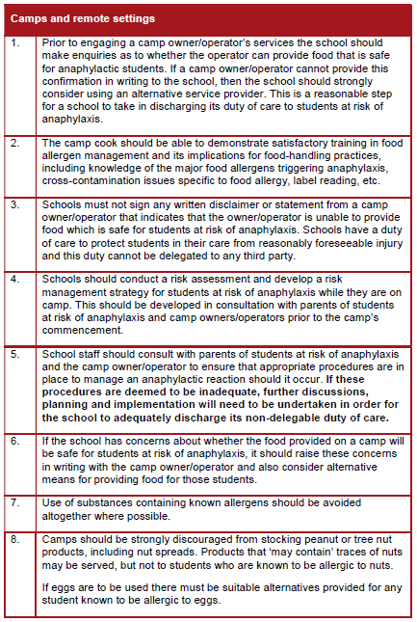

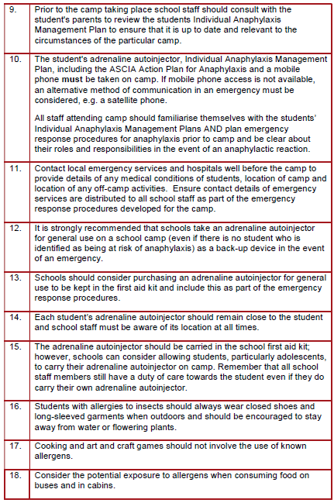

School Planning and Emergency Response

If reaction occurs outside on the Yard during RECESS or LUNCH:

- Yard duty teacher to stay with child.
- Teacher to give a student(s), photo identification card/red card from ‘bumbag’ to bring to office/staffroom
- Remove the allergen, if known, from the vicinity of the child.
- Staff member takes affected child’s EpiPen from the first aid room to the child
- A staff member rings for an ambulance on mobile phone and takes phone to the child to relay to the paramedic the child’s current condition. –THE STAFF MEMBER ASKS FOR MICA UNIT, STATING THAT THE EPIPEN WAS GIVEN AND THE TIME IT WAS ADMINISTERED. Advise the ambulance officer that the school has another EpiPen if needed. STATE WHICH GATE AMBULANCE IS TO ENTER THROUGH – Rocke St or Rockbeare Grove Do Not Hang Up!
- The School Emergency Management Plan will be put into place if required.
- Principal or Deputy or Office Staff are to notify parents.
- Nominated Staff to wait at nominated gate to guide ambulance.
- Principal or Deputy or Staff Member to travel to hospital with child if parents have not arrived.

If a reaction occurs in a CLASSROOM or a SPECIALIST lesson:

- The teacher will use Intercom to alert office that the EpiPen is required.
- Principal or Deputy Principal or Office Staff to take EpiPen to child.
- The office staff to ring ambulance on mobile phone and take phone to the child’s location, to relay to the paramedic the child’s current condition. – A staff member rings for an ambulance on mobile phone and takes phone to the child to relay to the paramedic the child’s current condition. –THE STAFF MEMBER ASKS FOR MICA UNIT, STATING THAT THE EPIPEN WAS GIVEN AND THE TIME IT WAS ADMINISTERED. Advise the ambulance officer that the school has another EpiPen if needed. STATE WHICH GATE AMBULANCE IS TO ENTER THROUGH – Rocke St or Rockbeare Grove Do Not Hang Up!
- Principal or Deputy or Staff Member to go to classroom to assist teacher.
- Principal or Deputy or Office Staff to notify parents.
- Staff member to wait at nominated gate to guide ambulance.
- Principal or Deputy or Staff Member to travel to hospital with child if parents have not arrived.

If a reaction occurs on an EXCURSION or SCHOOL CAMP:

- Staff member to administer EpiPen.
- A staff member rings for an ambulance on mobile phone and takes phone to the child to relay to the paramedic the child’s current condition. –THE STAFF MEMBER ASKS FOR MICA UNIT, STATING THAT THE EPIPEN WAS GIVEN AND THE TIME IT WAS ADMINISTERED. Advise the ambulance officer that the school has another EpiPen if needed. STATE ADDRESS FOR AMBULANCE. Do Not Hang Up!

- Another nominated Staff Member to wait for ambulance.
- Coordinator/staff member to ring parents and school.
- Staff member to travel to hospital with child.

Adrenaline autoinjectors for General Use
The school will purchase Adrenaline autoinjectors (Epipens) for general use and as a back-up for those supplied by the parents. They will be regularly checked by admin staff to ensure that they have not expired and are ready for use.

Individual student Epipens are kept in the first aid room. Usually only the Epipen belonging to each child should be used for that child.

Possible Signs and Symptoms of an anaphylactic reaction
- Hives/Rash
- Facial Swelling
- Tingling in or around mouth
- Abdominal pain/vomiting/diarrhoea
- Cough or wheeze
- Difficulty breathing or swallowing
- Breathing stops
- Loss of consciousness or collapse

All parents of children who require an EpiPen are required to complete an Action Plan for Anaphylaxis with a photo and a doctor’s signature. It is the parent’s responsibility to ensure that their child’s Action Plan and EpiPen are current.

(2019)

